A.Team Identity
Team name: Team 7
Business idea title: B-Sim AI: Strategic Business Simulation Platform for Higher Education
B. Executive Summary
Business Idea: B-Sim AI is an advanced, AI powered macroeconomic business simulation platform tailored specifically for higher education. Aligning perfectly with the theme of strengthening global relationships through sustainable innovation and technology, the platform immerses student teams in a shared virtual economy where they manage simulated companies. It transforms traditional business education into an experiential learning system by requiring students to make real time strategic decisions across finance, operations, marketing, and human resources, while continuously balancing profitability with mandatory sustainability constraints.
Target Market: The primary target market consists of higher education institutions, specifically universities, business schools, and entrepreneurship centers operating within the global B2B EdTech sector. With a strategic focus on the rapidly expanding Asia Pacific region, including Indonesia's extensive network of 4,400 universities, the platform addresses the growing administrative demand for measurable, practical learning outcomes and the global push to integrate sustainability into core academic curricula.
Uniqueness: B-Sim AI fundamentally differentiates itself from static case study methods and traditional simulation games through its proprietary AI driven evaluation engine. Instead of merely providing quantitative rankings, the AI functions as an intelligent auditor that automatically diagnoses strategic errors, such as inventory imbalances from overproduction or pricing misalignments leading to lost market share, and delivers personalized, qualitative feedback on exactly why specific decisions failed. Furthermore, the platform features a dynamic shared economy where every team's pricing and operational decision directly alters the competitive market conditions for all other participants, seamlessly embedding environmental and social governance as a core survival constraint rather than an optional module.
Financial Potential: Operating on a highly scalable B2B Software as a Service (SaaS) model, B-Sim AI generates stable, recurring revenue through flexible usage based fees ($15 to $30 per student) and annual institutional licensing tiers ranging from $3,500 to $15,000. The commercialization roadmap is exceptionally capital efficient, initiating with a lean $7,000 budget to develop a functional prototype over an 8 week sprint. Following successful institutional pilot testing and subsequent seed fundraising, the platform is projected to scale across 80 to 150 institutions, unlocking a substantial revenue potential of up to $1.5 million by the second year of full commercial operation.
C. Introduction
Business Opportunity & Supporting Factors: There is a critical opportunity in the higher education sector to transition from static, theoretical business education to experiential, AI-driven learning. This shift is strongly supported by three converging factors: the administrative demand for measurable practical learning outcomes, the accelerated adoption of AI in education since 2023, and the global push to integrate sustainability into core business curricula. Aligning with the theme of sustainable innovation and technology, B-Sim AI capitalizes on these factors, specifically addressing the needs of over 800 signatory institutions in the UN PRME network committed to responsible management education.
Market Demand: The market demand for scalable EdTech solutions is substantial, with the global EdTech market projected to reach $404 billion by 2025 at a 16.3% CAGR. The Asia-Pacific region accounts for approximately 24% of this total, with countries like Indonesia, Vietnam, and Singapore shifting rapidly toward scalable digital adoption. Indonesia alone provides a massive immediate market with 4400 universities as of 2025, ranking second globally in the number of higher education institutions.
Potential for Success: The platform's potential for commercial success is driven by its highly scalable B2B Software-as-a-Service (SaaS) model. Once embedded into official academic curricula, institutional EdTech platforms typically achieve robust annual retention rates of approximately 85%. This high retention, combined with the massive addressable market, creates a highly predictable revenue stream. By scaling to just 80–150 institutions in its second year, the platform is projected to unlock a substantial revenue potential ranging from $480,000 to $1.5 million.
D. Business Description
Business Concept
B-Sim AI is an advanced AI-powered business simulation platform designed specifically for higher education institutions. The platform operates by creating a shared virtual economy where student teams directly manage their own companies and make comprehensive strategic decisions across pricing, operations, finance, marketing, and human resources. Directly responding to the competition's theme of sustainable innovation and technology, the system not only simulates real-time macroeconomic volatility but also deeply integrates sustainability constraints into the core of every decision. This approach transforms traditional business education from passive theoretical learning into an experiential learning system, requiring students to continuously analyze financial data to balance short-term profit maximization with long-term sustainable performance
Product Uniqueness
The platform's uniqueness lies in its automated evaluation and feedback mechanism driven entirely by AI. Unlike standard simulation games that only provide quantitative scores and rankings, B-Sim AI functions as an intelligent, automated performance audit. After each simulation round, the AI system automatically evaluates every team's decisions, accurately diagnoses strategic errors such as inventory imbalances from overproduction or pricing misalignments leading to lost market share and delivers personalized strategic analysis and improvement recommendations for the next stage. Furthermore, because the virtual economy is dynamic and interactive, one team's decisions directly alter the competitive landscape for all others, creating a highly realistic environment that demands continuous adaptation for survival.
Core Strengths
The core competitive advantage of B-Sim AI is its ability to thoroughly address the limitations of static case-study methods, while significantly optimizing the workload for instructors. Running a business simulation class typically requires massive resources for grading and tracking, but this platform fully automates financial and human resource monitoring. The system continuously tracks key metrics such as revenue, costs, EBITDA, and profit margins, consolidating them into visual dashboards for faculty. This automation completely eliminates manual grading, allowing instructors to efficiently manage large student cohorts, thereby delivering exceptional scalability and strong commercial adoption potential across universities.

E. Segmentation, Targeting, and Positioning
The platform strategically segments its market into two main institutional categories: higher education institutions, such as universities and business schools focused on formal curricula and long-term graduate outcomes, and innovation ecosystems, including entrepreneurship centers and incubators emphasizing practical venture development. Within these segments, the primary target market is universities and business schools, which perfectly align with the platform’s B2B Software-as-a-Service (SaaS) model. These institutions possess stable annual budgets for educational technology and typically integrate simulation tools directly into their official academic curricula. This structural integration creates high switching costs and robust long-term retention rates across student cohorts, making universities a highly predictable, scalable, and valuable customer base. By securing adoption at the faculty or administrative level, the platform guarantees large-scale mandatory usage without the need for individual student acquisition.
In terms of product positioning, B-Sim AI is defined as an experiential, data-driven, and sustainability-focused learning system designed for higher education. Unlike traditional lecture-based methods, standard simulation games, or generic AI tutors, this platform seamlessly combines virtual company management, dynamic market simulation, and real-time financial dashboards into one integrated environment. The platform provides a unique learning loop through AI-driven feedback that not only evaluates financial outcomes but deeply analyzes the strategic intent behind every operational decision. Furthermore, for universities seeking to modernize their business education, the platform fundamentally embeds sustainability into the core decision-making process. Rather than treating environmental and social governance as a separate module, the system forces students to continuously balance profitability, market risk, and ethical impact, delivering an interactive simulation that authentically mirrors modern real-world business complexities.
F. Demand and Competitor Analysis
Market Demand
The global EdTech market is projected to reach $404 billion by 2025 at a 16.3% CAGR, with Asia-Pacific representing approximately 24% of that total. Southeast Asia particularly Indonesia, Vietnam, and Singapore is shifting from early-stage experimentation to scalable adoption. Demand for this platform is driven by three converging pressures: universities needing measurable practical learning outcomes, accelerated AI adoption in education since 2023, and the global integration of sustainability into business curricula. The UN PRME network alone counts over 800 signatory institutions committed to responsible management education. Indonesia has 4,400 universities as of 2025, ranking second globally even though low penetration across the region represents a significant market.

Competitor Analysis
The competitive landscape spans four categories: business simulation platforms, case-based learning tools, LMS platforms, and general AI tools. None combine all three defining elements of this platform: a live shared competitive economy, AI-generated personalized feedback, and sustainability embedded as a decision constraint.

Competitor | Type | What They Offer | Key Limitation | Our Differentiation
Capsim (1,000+ institutions) | Business Simulation | Multi-round competitive simulation: strategy, finance, marketing, HR | Feedback is score/rank-based; no AI explanation of why decisions failed | AI post-round critique pinpoints exact decision, cause, and correction
Harvard Business Publishing | Case-based Platform | Structured simulations with fixed scenario and outcome logic | Pre-scripted; one team's actions don't affect other teams' market | Shared economy every team decision reshapes conditions for all others
Generic LMS (Canvas, Moodle) | Learning Management | Content delivery, assignments, gradebook | No simulation; students consume content, not run businesses | Students manage live virtual companies with real P&L across rounds
General AI Tutors (ChatGPT) | AI Education | Q&A, explanations, study support | Cannot simulate competition or evaluate real team decisions in context | AI evaluates actual decisions made by real teams in a live environment
Table F.1 Competitor comparison. Cesim client data sourced from cesim.com. All other assessments based on publicly available product documentation.
Planned Sales Volume and Revenue Projections
The platform will generate revenue through institution-level annual licensing, benchmarked against comparable tools like Cesim which range from $3,000 to $15,000 per year. The go-to-market strategy will follow a pilot-first approach beginning with subsidized deployments in 2–3 universities to generate performance data and testimonials before moving to paid adoption. Once embedded in course structure, B2B institutional EdTech platforms tend to achieve annual retention rates of approximately 85%, making early adoption investment disproportionately valuable over the long term.

Stage | Timeframe | Target Institutions | Est. License / Year | Projected Revenue Range
Prototype & Pilot | Week 1–8 | 1–3 universities (subsidized/free) | — | Non-monetary: feedback, testimonial, case study data
Early Adoption | Month 3–6 | 5–10 institutions | $3,500–6,000 | $20,000–$60,000
Growth Phase | Month 7–12 | 20–40 institutions | $5,000–8,000 | $100,000–$320,000
Scale (Year 2) | Month 13–24 | 80–150 institutions | $6,000–15,000 | $480,000–$1,500,000
Table F.2 Projected sales volume and revenue by adoption stage. Revenue ranges are estimates based on comparable EdTech institutional pricing benchmarks and do not represent guaranteed outcomes.
G. Operational Plan

Service Process - How the Simulation Runs
The platform will operate through a structured simulation cycle where each round represents one business quarter. Instructors will configure the session once; the AI engine will handle all evaluation and feedback automatically throughout. The sustainability layer will not function as a separate event; it will be embedded into every decision category, with delayed consequences surfacing in later rounds to replicate how real-world business trade-offs unfold over time.

1 | Platform Setup | The instructor will configure rounds, market scenarios, scoring weights, and sustainability constraints for the session.
2 | Team Onboarding | Teams will receive virtual companies with identical starting resources and baseline market conditions.
3 | Decision Round Opens | Teams will review market briefs and submit decisions across pricing, operations, finance, hiring, and sustainability.
4 | Simulation Engine Processes | The AI engine will calculate outcomes for all teams simultaneously, applying competitive dynamics and live market events.
5 | Results & AI Feedback | Each team will receive financial results and a personalized critique: what failed, why it happened, and what to adjust next round.
6 | Next Round / Final State | The cycle will continue until the final round, which will produce cumulative rankings and an AI strategic summary per team.

Table G.1 Simulation cycle: six-step operational flow from instructor setup to final round output.
Organizational Structure
For the prototype and early-adoption phase, the team will operate as a lean five-function structure. Each role will map directly to a core deliverable, with no redundant layers, and team members will be expected to overlap where capacity requires

Role | Responsibilities | Team Size | Tools / Stack
Platform Development | Backend infrastructure, simulation engine, database, API architecture | 2 developers | Node.js / Python, PostgreSQL, REST API
AI Integration | Scenario generation logic, decision analysis engine, personalized feedback module | 1–2 developers | Python, LLM API (Anthropic / OpenAI), ML pipelines
UI/UX Design | Student dashboard, instructor panel, financial visualizations, mobile responsiveness | 1 designer | Figma, React.js, Tailwind CSS
Testing & QA | Functional testing, simulation logic accuracy, performance benchmarking | 1 QA lead | Jest, manual testing protocol
Operations & Outreach | University partnerships, onboarding, support, institutional marketing | 1–2 members | CRM, email outreach, demo decks
Table G.2 Functional team structure for prototype and early-adoption phase.
Infrastructure and Resources
The platform will be delivered as a cloud-hosted web application accessible from any modern browser and device, requiring no client-side installation from students or institutions. Core infrastructure will run on standard cloud services (AWS, GCP, or Azure) with usage-based pricing, keeping early-stage costs low and allowing the system to scale proportionally with adoption. The AI feedback engine will use a large language model API rather than an in-house trained model, keeping development scope realistic while delivering high-quality, context-aware qualitative output after each simulation round.
Management Methods
Development across all four phases will follow a sprint-based workflow with each time block mapped to a defined deliverable, from the 8-week prototype build through the Month 19–24 national commercial expansion, ensuring every stage in Section J will produce a concrete, reviewable output. All code will be version-controlled through Git with a mandatory peer review before any merge, a non-negotiable requirement that will hold from Week 1 through Month 24, given that simulation logic errors at any stage could directly undermine instructor confidence and institutional retention. Each new partner university, whether a subsidized pilot in Weeks 4–6 or a paying institution onboarded during the Month 3–6 early adoption or Month 13–18 regional scaling phases, will move through the same four-step onboarding protocol: technical setup, instructor walkthrough, student orientation, and a structured end-of-semester debrief. Debrief feedback will feed directly into the product backlog at every phase, driving sprint priorities in Months 3–6, LMS integration decisions in Months 7–9, B2B campaign positioning in Months 10–12, and customer success operations in Months 19–24 that will sustain the 85% retention rate underpinning Year 2 revenue projections.

H. Marketing Strategy (7Ps Framework)

Details the Product
B-Sim AI is an AI-driven macroeconomic simulation platform featuring real-time dashboards, an executive decision core, and an automated evaluation assistant that generates dynamic, non-repetitive market environments
Price
The hybrid pricing model combines flexible usage-based fees (15–30 per student/term) with annual institutional SaaS tiers ranging from $3,500 (small cohorts) to $15,000 (enterprise unlimited access).

Promotion & Placement
Distribution is executed seamlessly via direct Learning Management System (LMS) integration (SSO/LTI). Promotion relies on consultative academic alignment, efficacy reports, and student brand ambassadors rather than aggressive direct sales.
Process, People & Physical Evidence
A structured 5-stage onboarding pipeline is actively supported by instructional designers and customer success managers to ensure high retention. Institutional trust is further reinforced by enterprise-grade UI/UX, published impact whitepapers, and tangible prestige markers from simulation championships.

I. Business Analysis
A strategic assessment reveals how the platform's core technology interacts with market opportunities and operational realities.
Figure I.2: SWOT Analysis evaluating the strategic positioning and market risks.

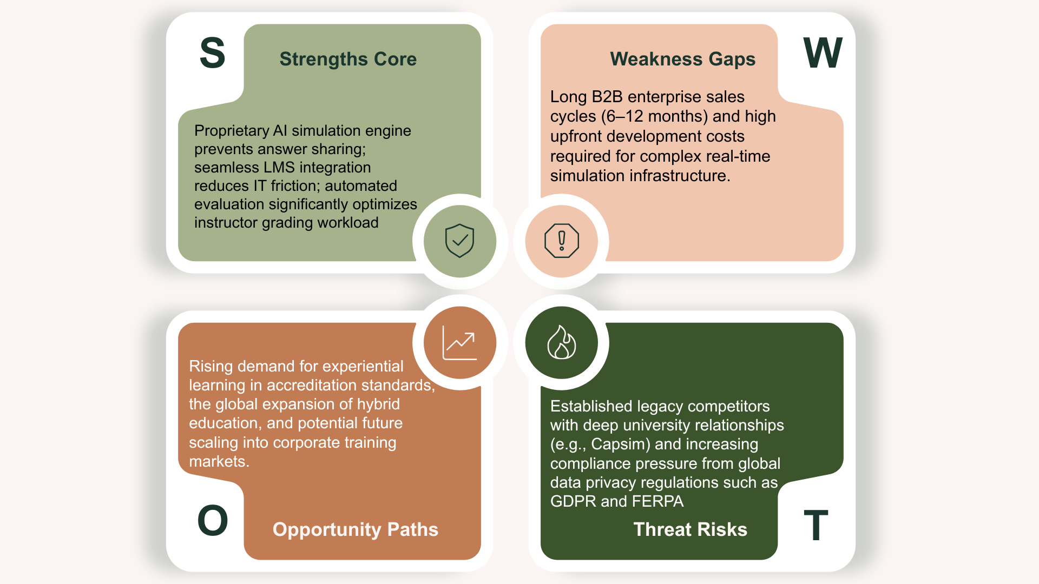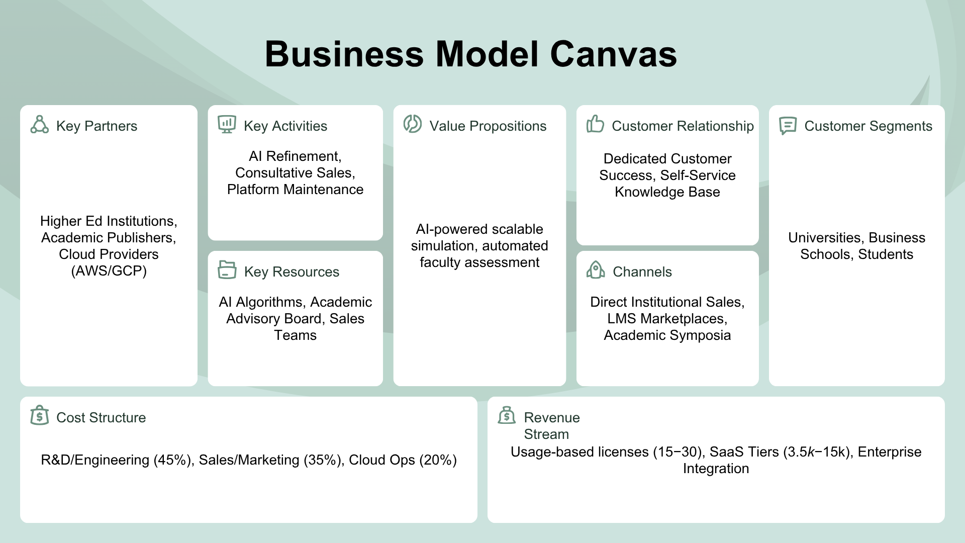
Figure I.2: Business Model Canvas outlining the operational and revenue framework.
Mockup

The following mockups illustrate the core interactive interfaces of the B-Sim AI platform. These specific dashboards provide student teams with real-time analytics on their human resource allocation, workforce performance metrics, and comprehensive income statements. By visualizing these complex operational and financial datasets, the platform enables students to continuously monitor their operational efficiency and make data-driven strategic adjustments in response to the dynamic simulation environment.
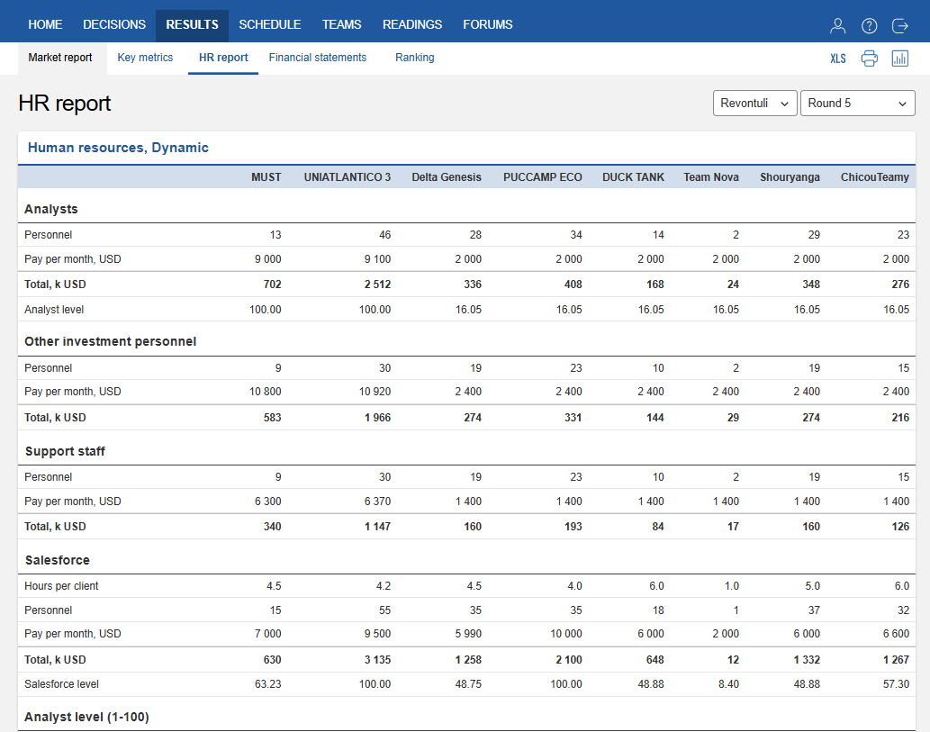
Figure I.3: B-Sim AI interactive student dashboard featuring detailed Human Resources performance analytics and dynamic financial reporting.

J. Activity Timeline

Phase | Time | Activity Stage | Description
1 | Week 1-3 | Building Core system & AI Development | Design UI/UX, set up core databases, and program AI features.
 | Week 4-6 | Prototype and pilot launch | Deploy MVP to 1–3 pilot universities and collect user feedback.
 | Week 7- 8 | Optimization & Commercial Prep | Fix bugs from pilot data and finalize B2B licensing models.
2 | Month  3-6 | Early Adoption Launch | Formally launch platform and onboard 5–10 paying institutions.
3 | Month  7-9 | LMS Integration & Feature Expansion | Build Canvas/Moodle API integrations and upgrade simulation features.
 | Month 10-12 | Aggressive B2B Growth | Scale marketing outreach to secure 20–40 new institutions.
4 | Month  13-18 | Partnership & Ecosystem Scaling | Partner with regional education boards and expand cloud infrastructure.
 | Month  19-24 | Full Commercial Dominance | Run national sales campaigns to onboard 80–150 institutions.

K. Capital Sources and use

This initial $7,000 funding is not intended to sustain the entire 24-month roadmap. Upon the successful completion of Phase 1 backed by verified product data and user testimonials from pilot universities,the company will raise a Seed Funding Round of $100,000 – $150,000 from Angel Investors or Venture Capital.
This upcoming institutional investment, combined with the projected Early Adoption revenue of $20,000–$60,000 generated in Months 3–6, will fully fund the LMS integration, B2B sales team expansion, and large-scale cloud operations required to achieve the Year 2 growth targets.

Capital Source | Amount | Description
Team Contribution | $7,000 | Initial funding from team members for early development.
Total Capital Sources | $7,000

Capital Allocation Phase 1 | Amount | Purpose
Building Core System & AI Core Development | $3,150 | UI/UX design, database setup, and core AI model training.
Cloud Infrastructure & Setup | $1,750 | Server deployment to support traffic for 1–3 pilot universities
B2B Outreach & Marketing | $1,400 | Preparation of pitch materials and institutional sales efforts
Contingency & Legal | $700 | Operational buffer and basic intellectual property protection.
Total Capital Allocation Phase 1 | $7,000

REFERENCES
Annur, C. M. (2023). Indonesia becomes the second country with the most universities in the world in 2023. Databoks, Katadata Indonesia. https://databoks.katadata.co.id/en/demographics/statistics/db7aab0ca2c0d6d/indonesia-becomes-the-second-country-with-the-most-universities-in-the-world-in-2023
Cesim Business Simulations. (n.d.). Educational services. Cesim Oy. https://www.cesim.com/solutions/educational/services
Culta.ai. (2026, April 2). EdTech benchmarks 2026: ARPU, retention and seasonality. https://culta.ai/benchmarks/edtech-benchmarks
Directorate General of Higher Education, Republic of Indonesia. (2022). List of universities in Indonesia. As cited in Wikipedia. https://en.wikipedia.org/wiki/List_of_universities_in_Indonesia
HolonIQ. (2020). Sizing the global EdTech market: Mode vs model. https://www.holoniq.com/notes/sizing-the-global-edtech-market
HolonIQ. (2024, November 26). HolonIQ annual education outlook 2025. QS Newsletters. https://newsletters.qs.com/holoniq-annual-education-outlook-2025/
HolonIQ. (2025, November 11). 2025 Southeast Asia EdTech 50. https://www.holoniq.com/notes/2025-southeast-asia-edtech-50
Loyalty.cx. (2025, June 22). The EdTech retention problem: Why learners keep cancelling. Loyalty Customer Experience. https://loyalty.cx/edtech-retention-problem/
United Nations Global Compact & Principles for Responsible Management Education. (n.d.). PRME signatory search. Retrieved May 26, 2026, from https://www.unprme.org/search/

